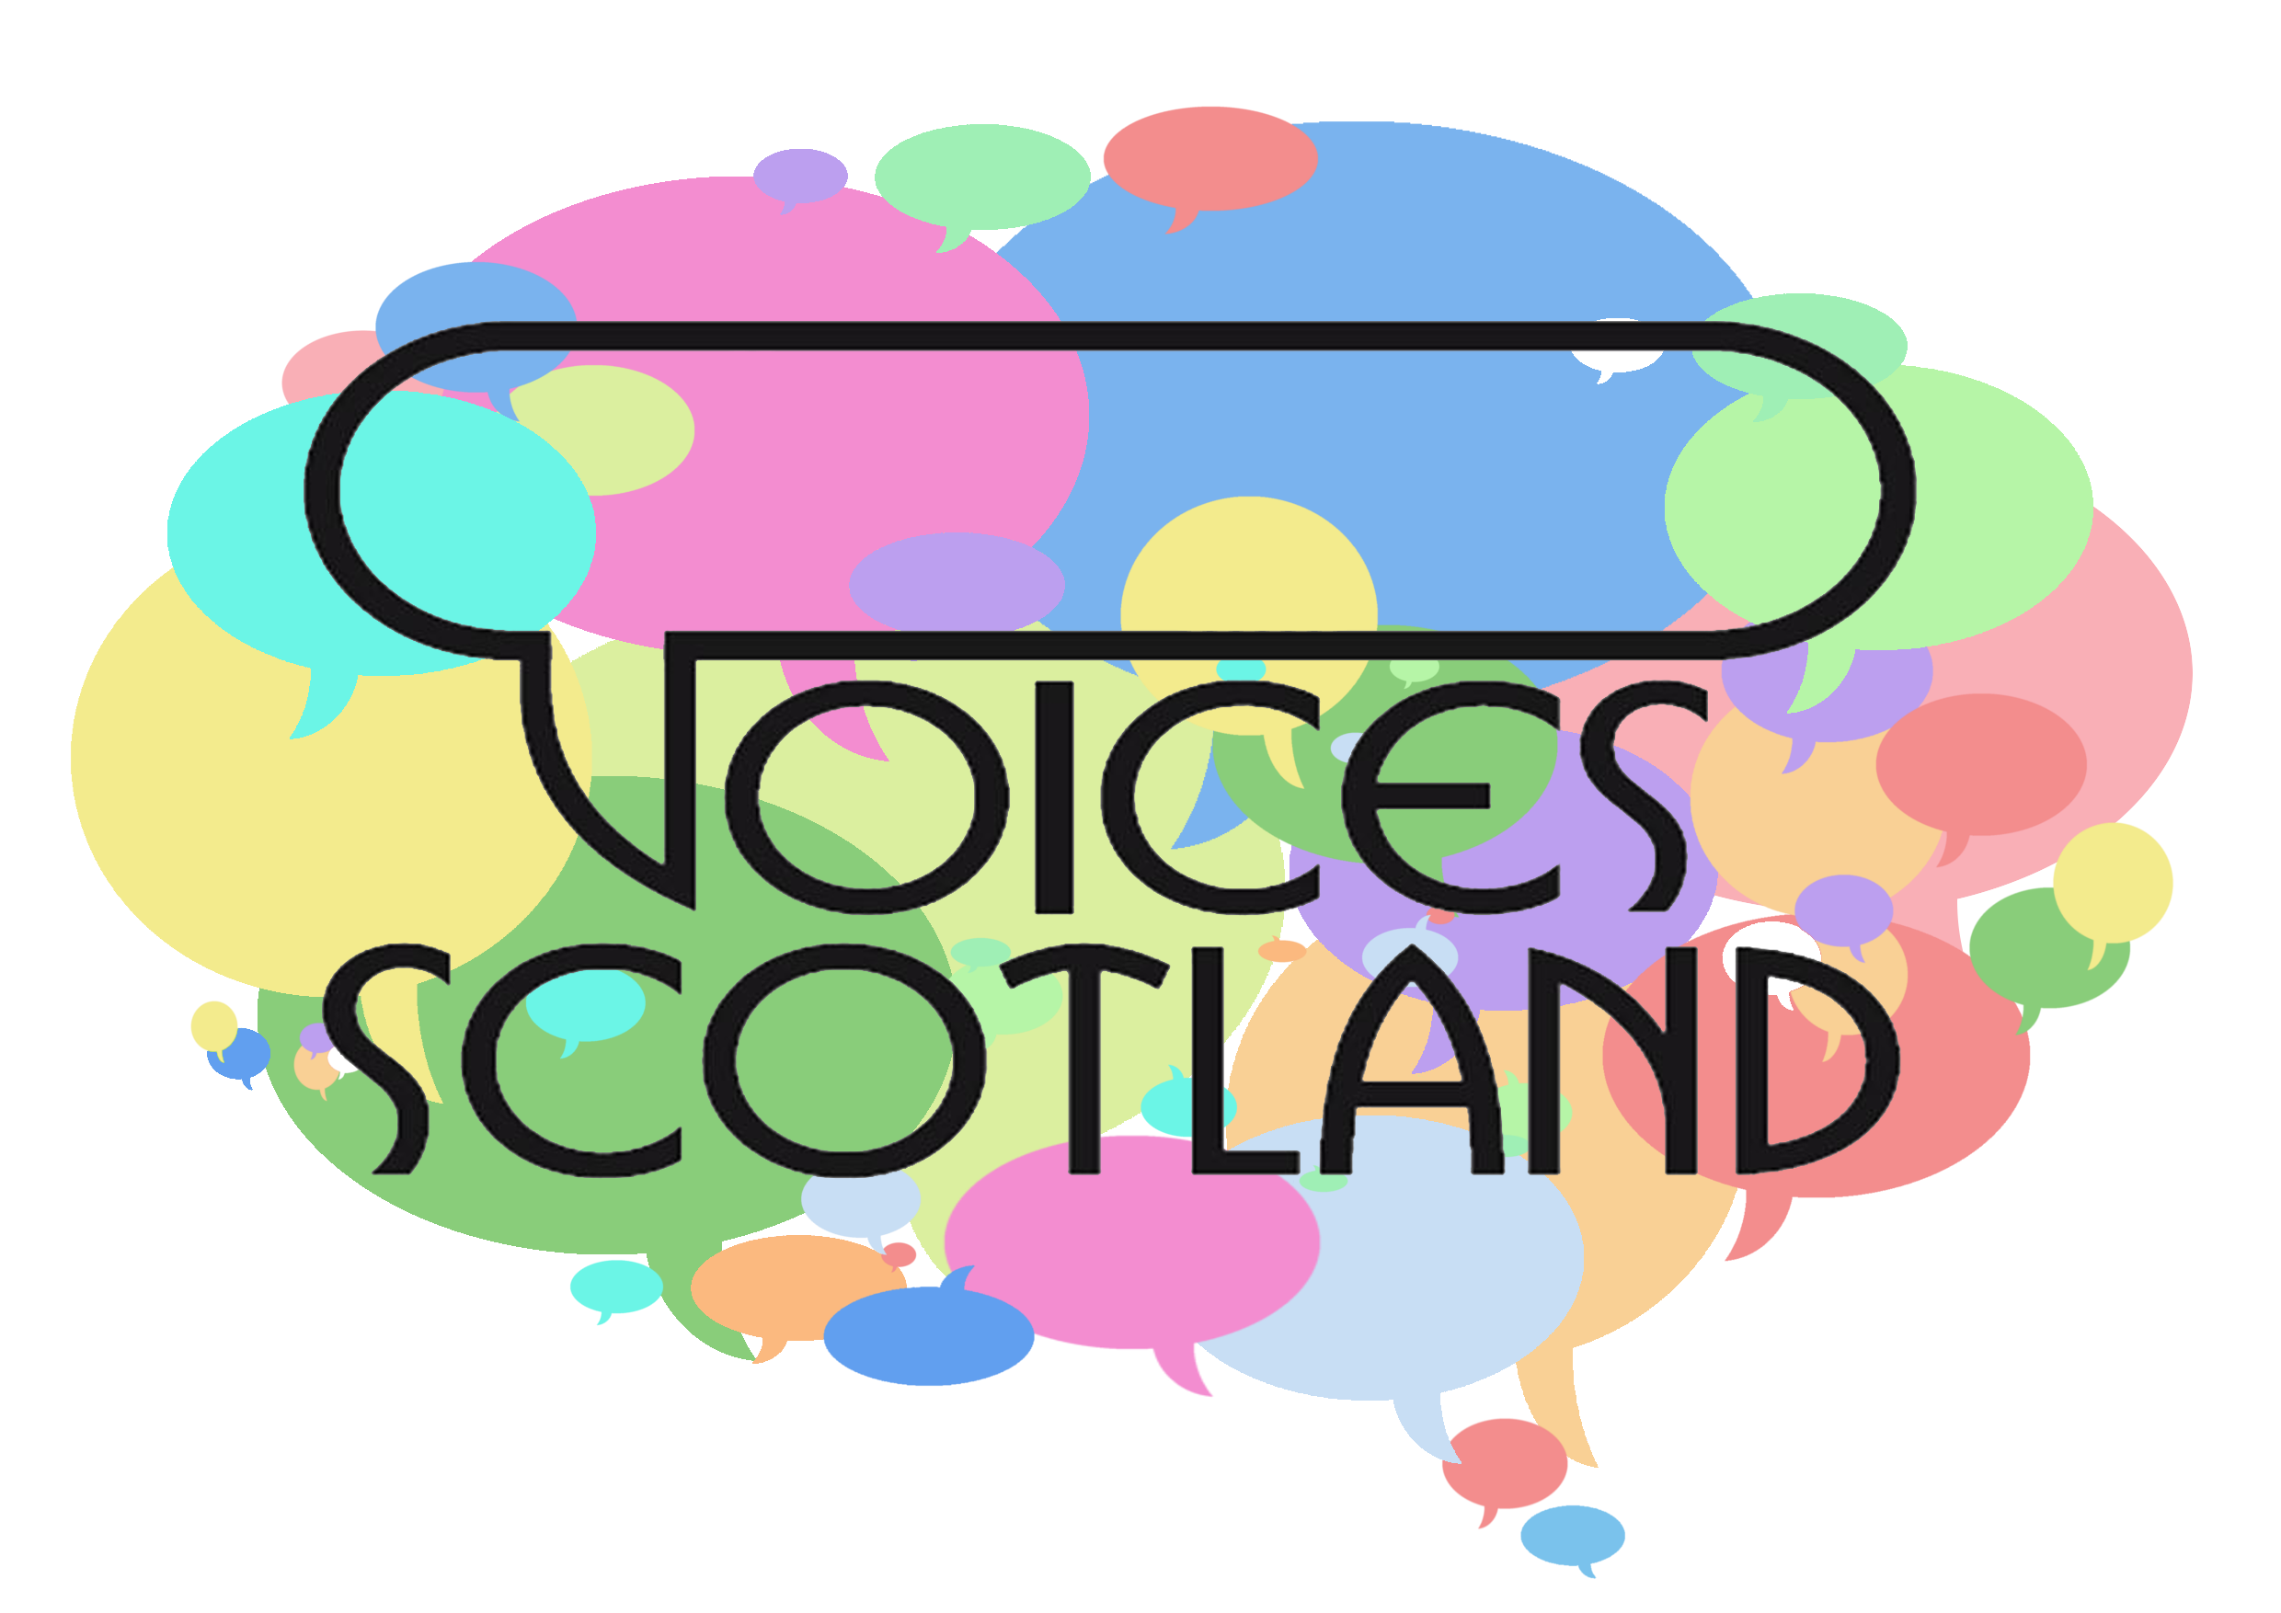
Making a Case for Change
What is the issue? Remember to be clear, focused, and specific
How do you know the issue exists? What is your evidence?
What has been the patient/carer/community experience?
How has the issue affected staff?
What are the national guidelines on the topic?
What are the local guidelines saying on the topic? Are any relevant?
How exactly do you want things to change?

